LAB Exercise No.1
Q1: Only 1 Http Get request message has been send.Packet no. 66 Contains the GET message.
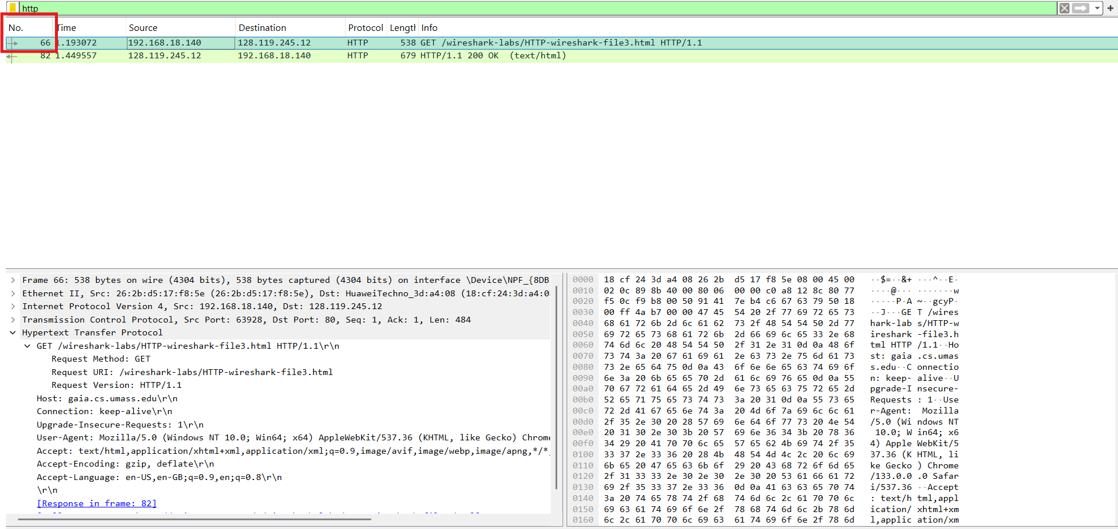
Q2: Packet no. 82
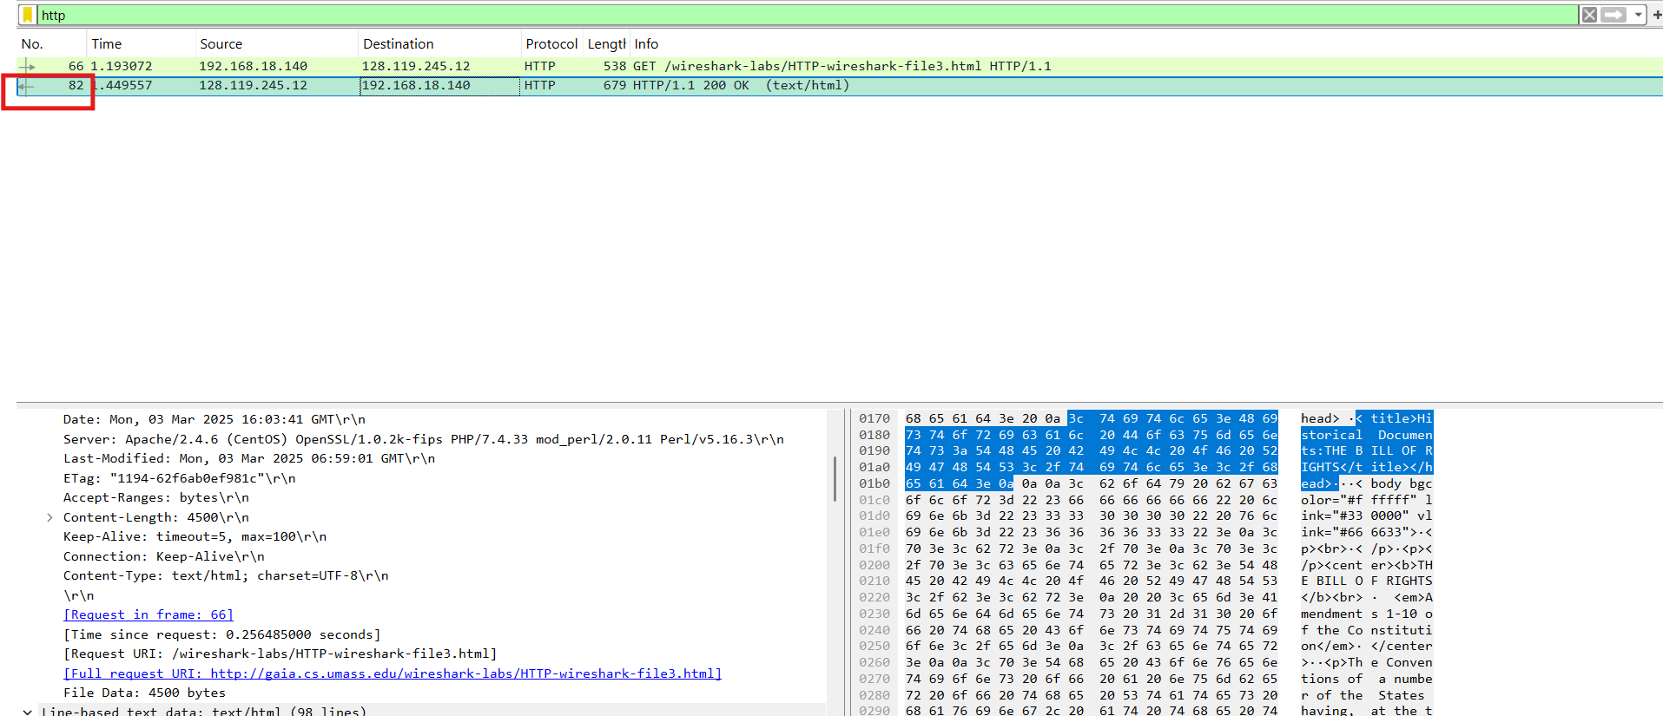
Q3: Status Code is 200 and response phrase is “OK”.
Q4: 4 TCP Segments were needed to carry single HTTP response.
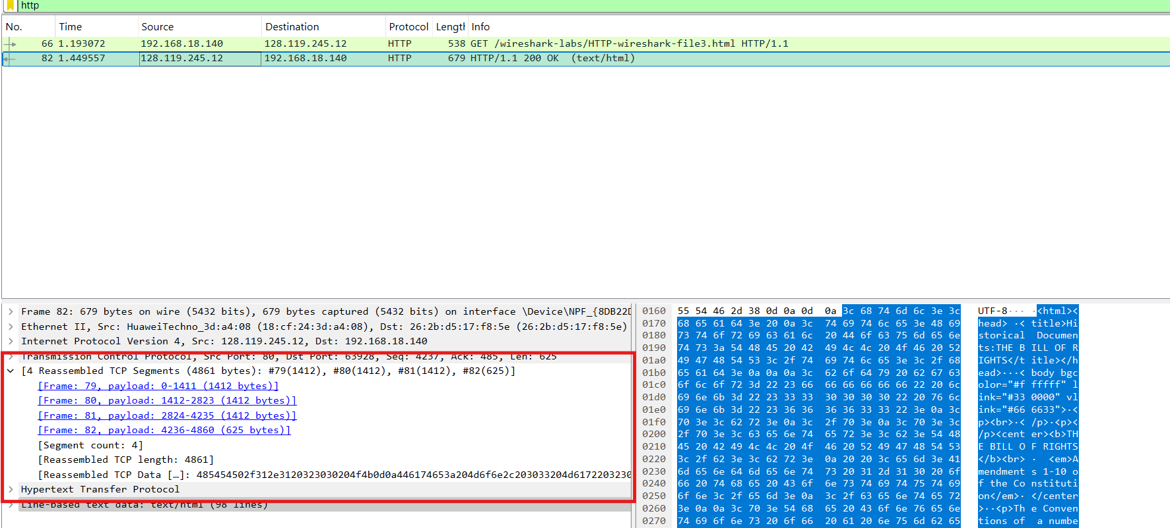
LAB Exercise No. 2

Q1: My IP Address: 192.168.18.140
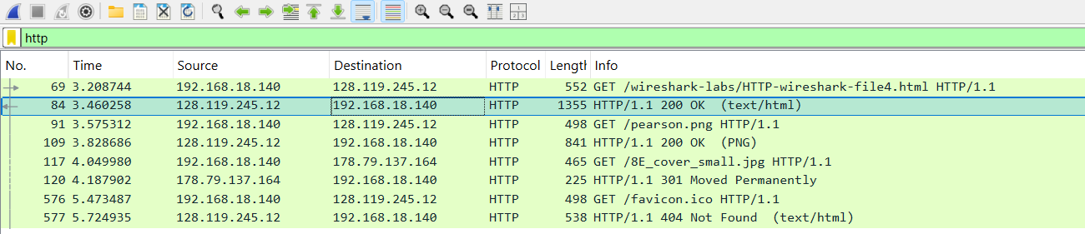
4 HTTP GET Requests were send.
1st GET request was send from my pc to server (128.119.245.12).
2nd GET request was again send to 128.119.245.12
3rd GET request was send to server (178.79.137.164).
4th GET request was send to server (128.119.245.12).
Q2: 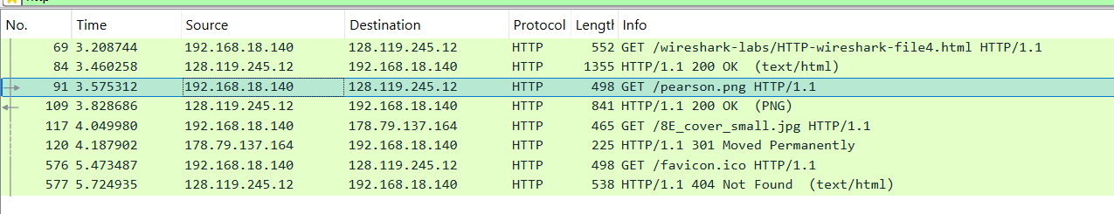
Browser downloaded the images serially as the second GET request starts only after the first GET response is received.
LAB Exercise No. 3
Q1: Status code is 401, and Response phase is “Unauthorized”.
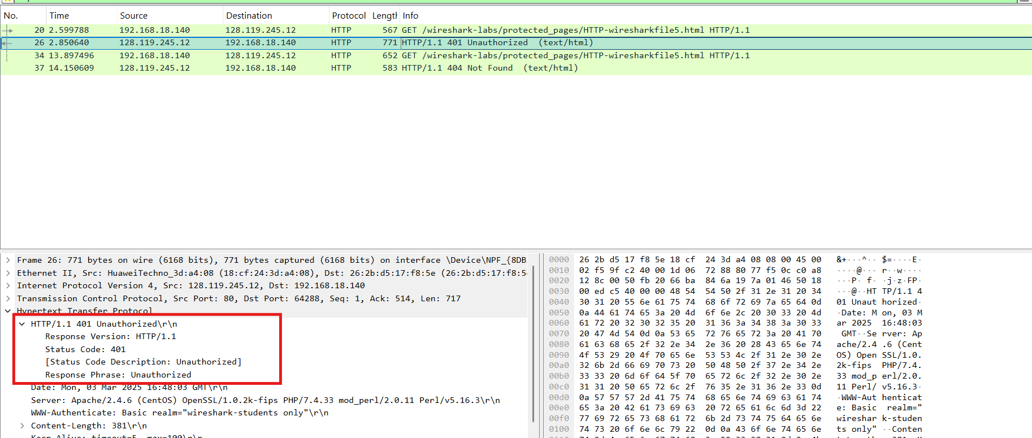
Q2: Authorization field is now included in the 2nd GET Request message.
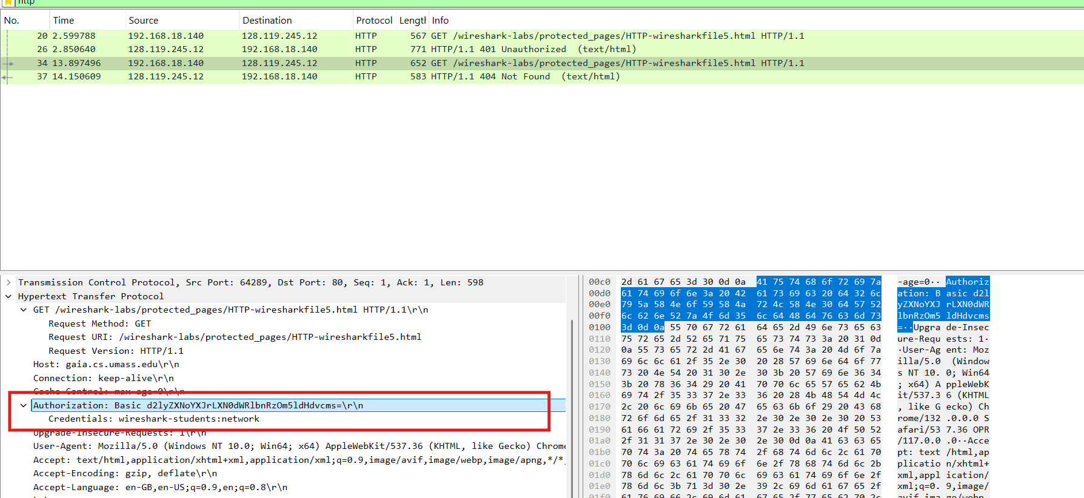
Lab Exercise No. 4 (Solved using my own traces as offline trace file not working)
Q1: The Client Ip Address is 192.168.18.140 and Source Port No. is 64396
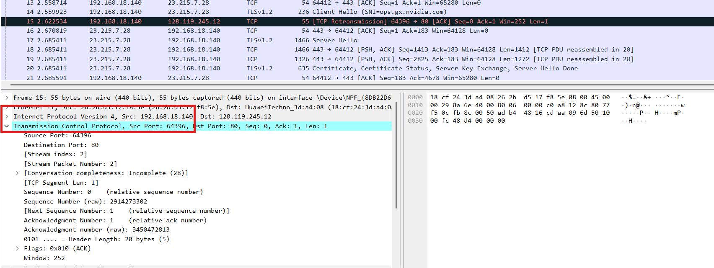
Q2: Ip address of gaia.cs.umass.edu is 128.119.245.12 and it is using Port 80 to send and receive TCP segments.
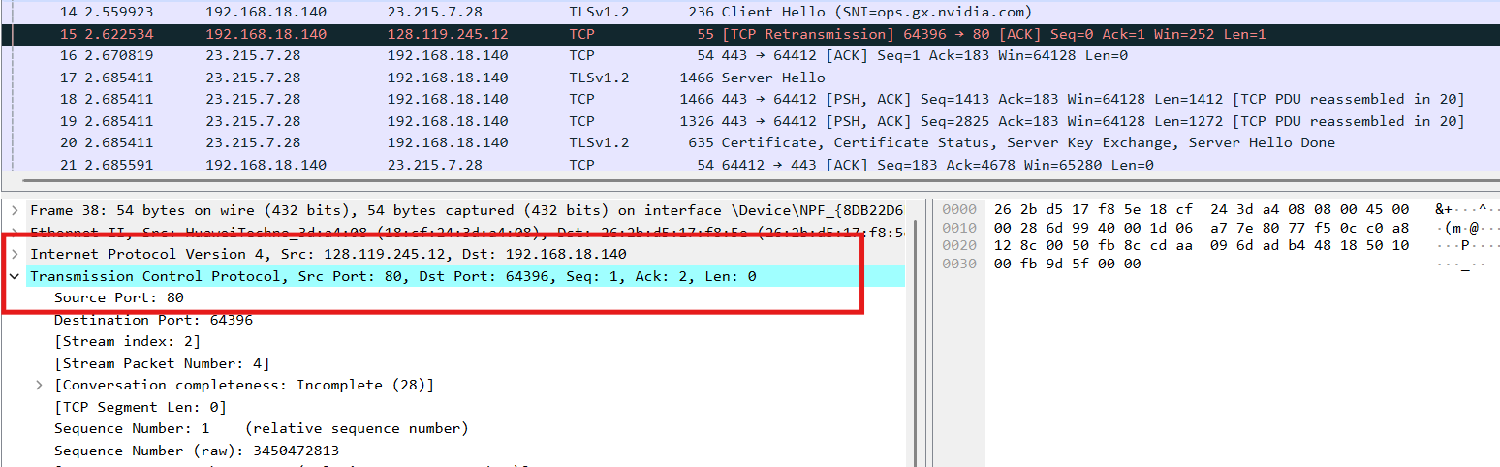

Q3: My Ip address: 192.168.18.140 and TCP Port Number used by my pc is 64396
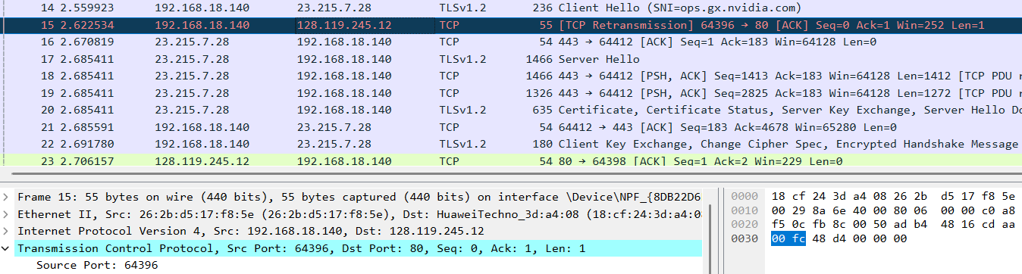
Lab Exercise No. 5
DIAGRAM:
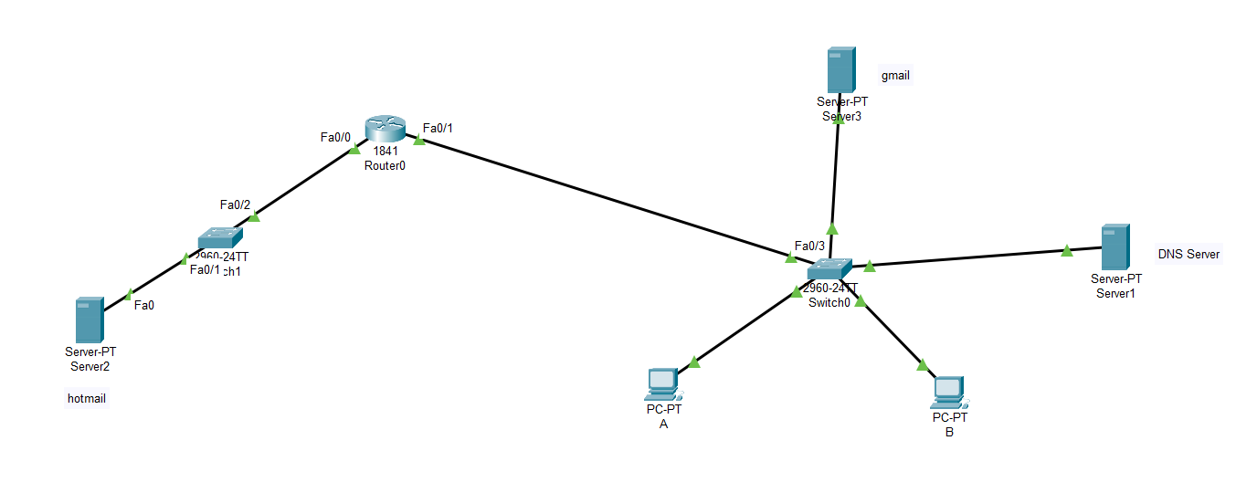

Configurations:
PC A config:

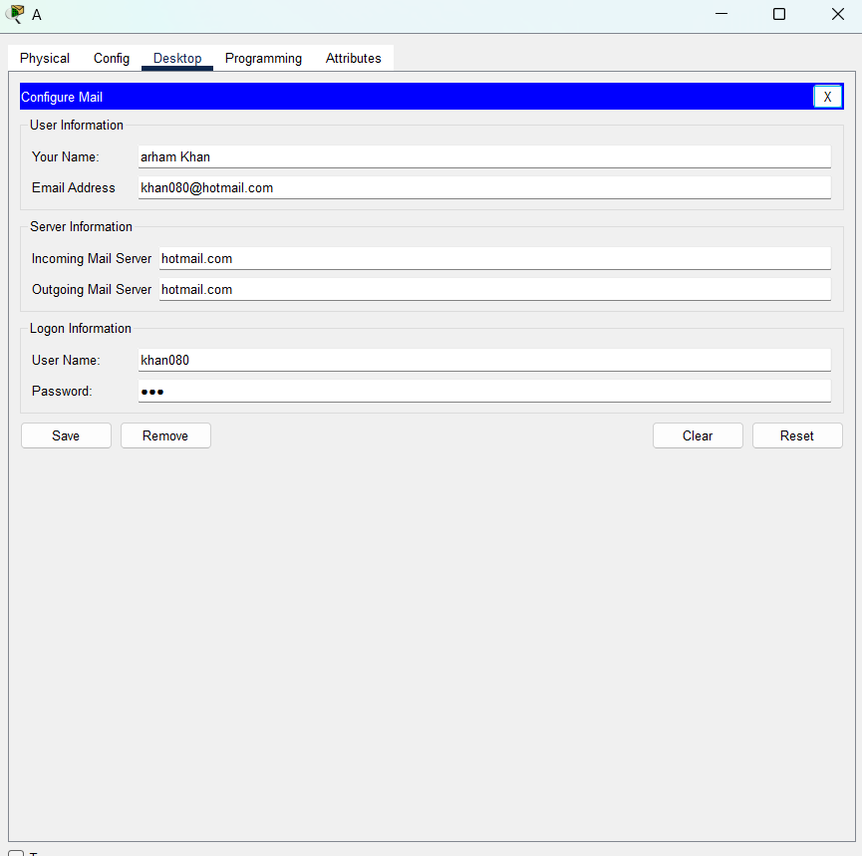
PC B Config:
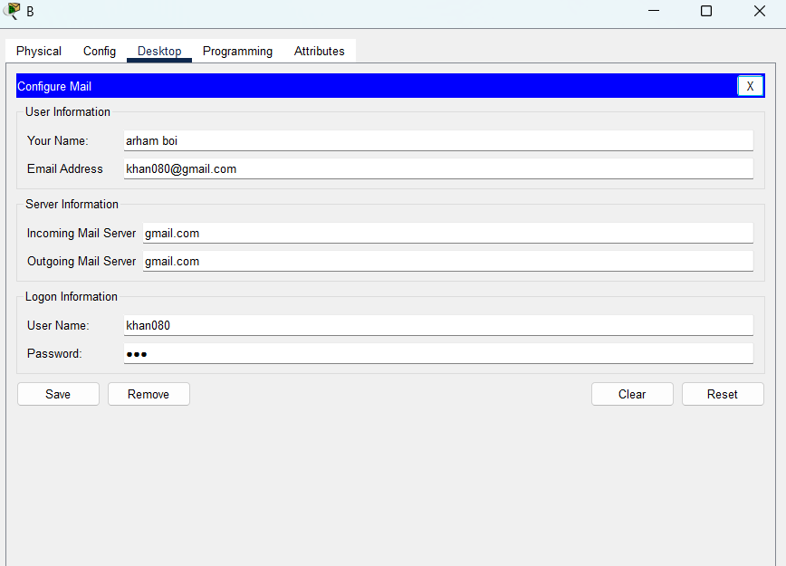

DNS Server Config:
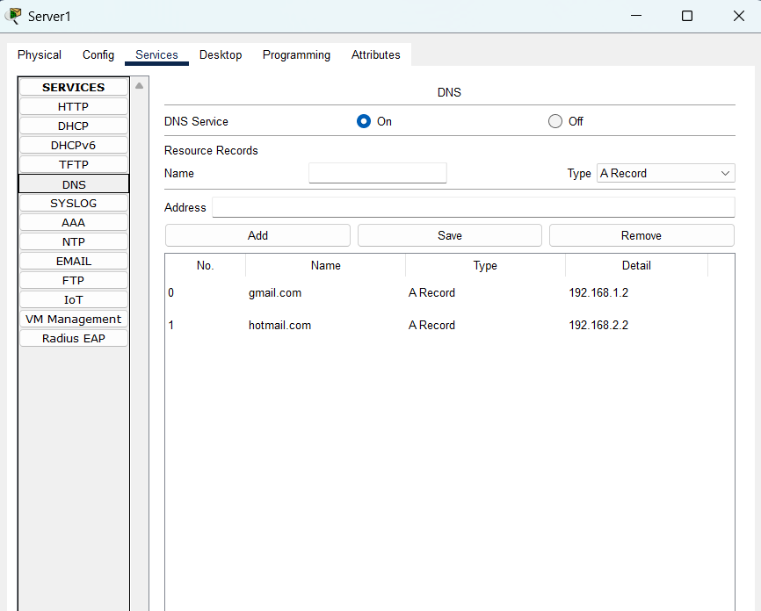
GMAIL SMTP Server:
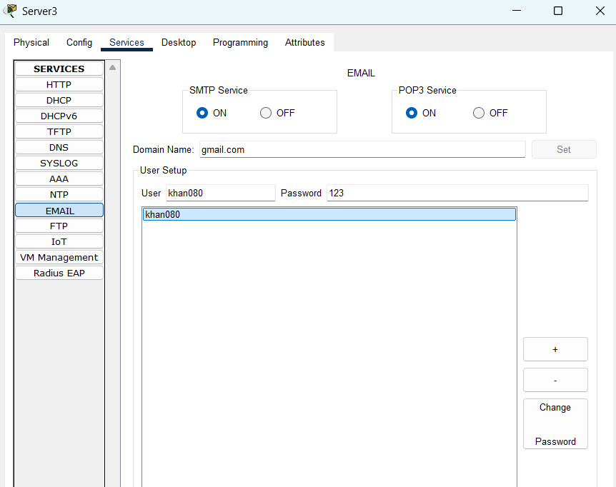

HOTMAIL SMTP Server (On different Network):
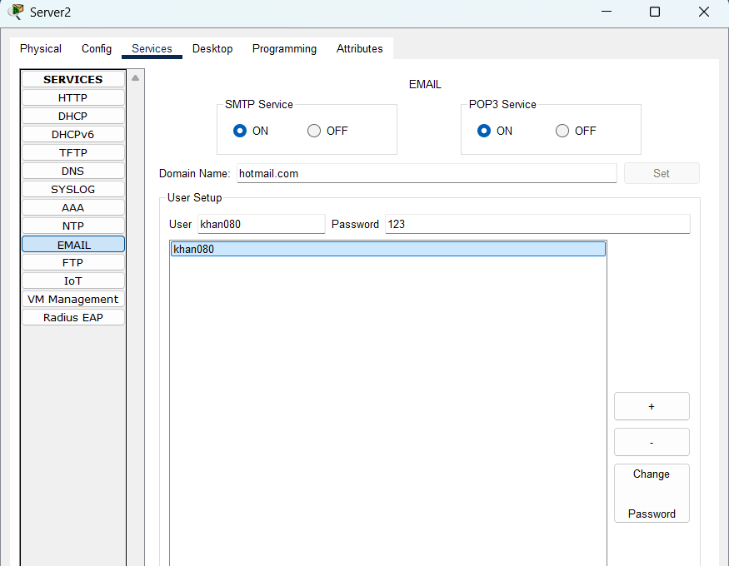
Mail send and receive:
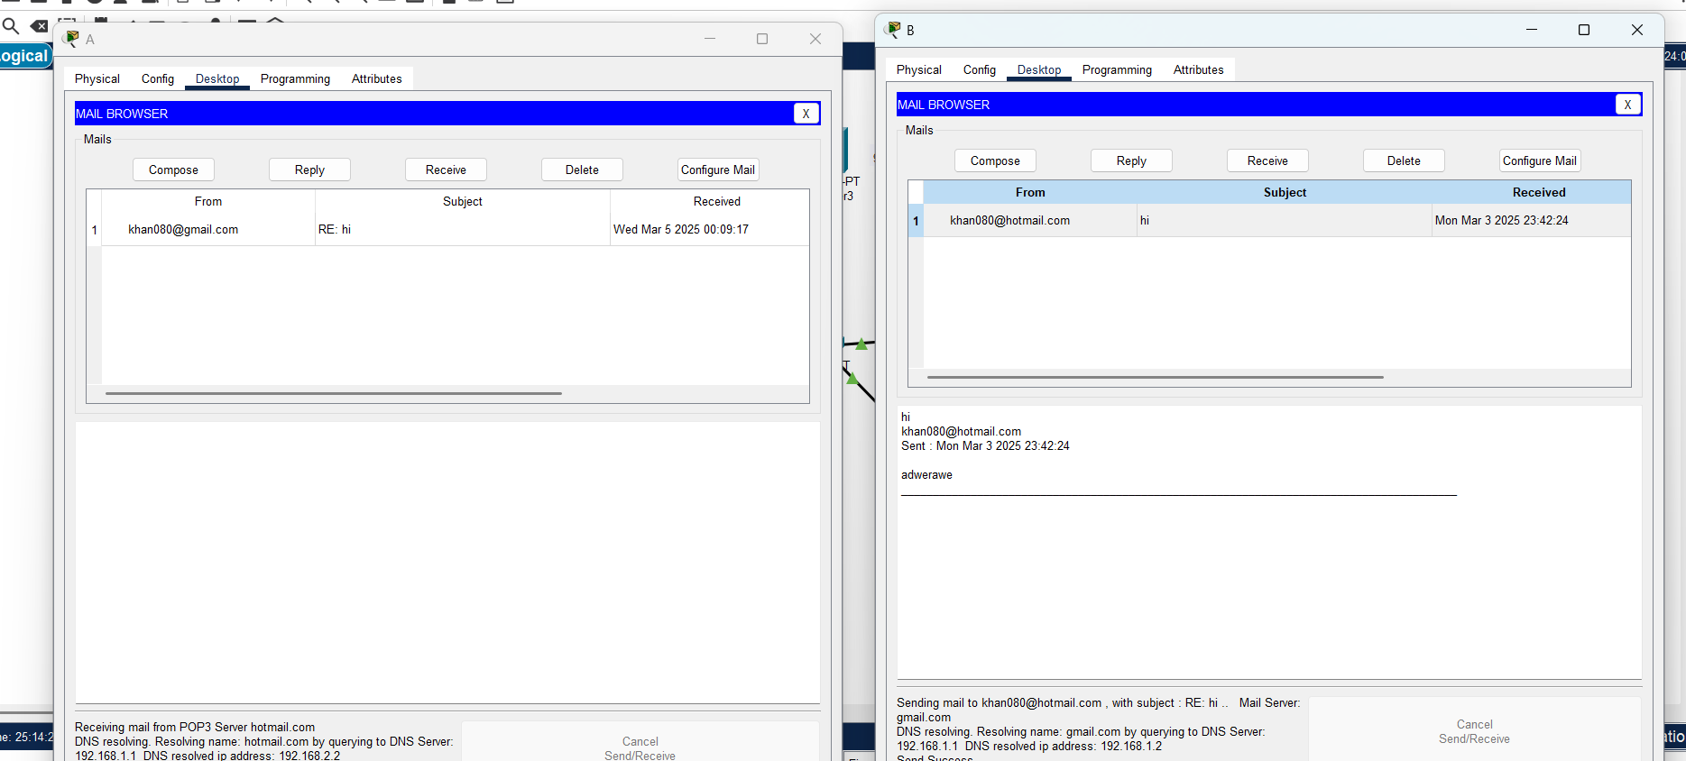

TASK C (FTP):
ftp on server 2:
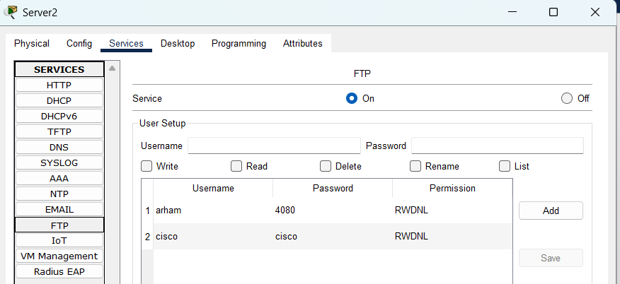
ftp on server 3:
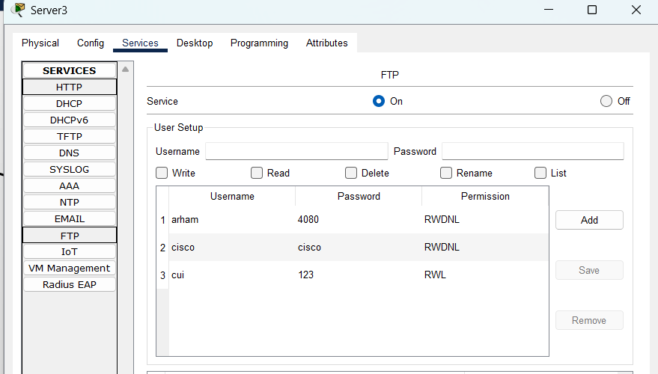
Command line :

Connection from server 2 (diff network):
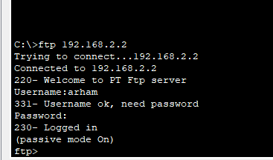
Connection from server 3(same network):
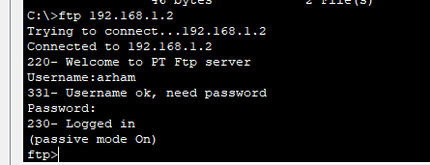
Bin file:
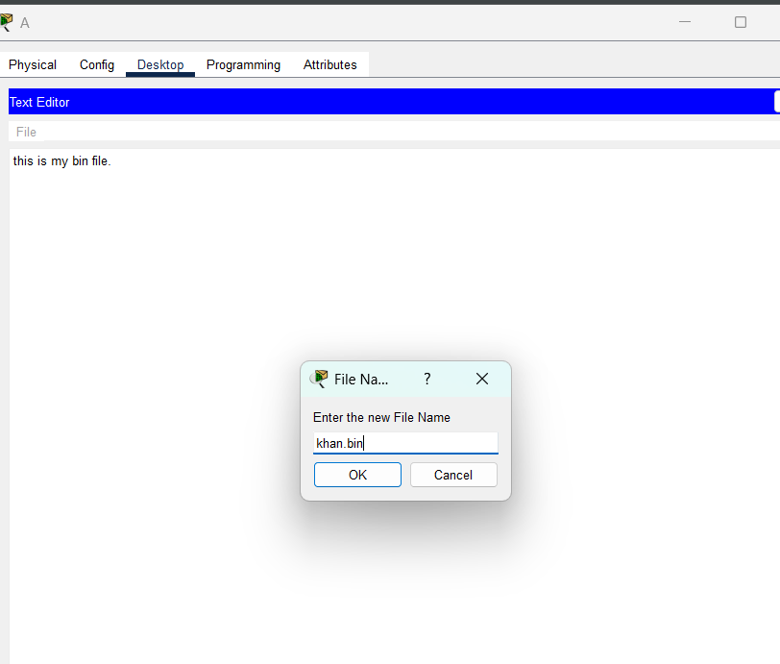
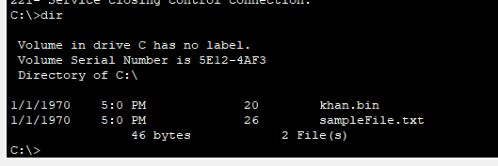
Uploading to server:
